Bus Terminal Ridership Forecasting, Analytics, and Data Warehouse Development

Course: Database Project 6430

Date: 1st Dec 2025

Student Name : Sushmitha reddy

Student ID : 00952452

Role : PowerBI Dashboard & Visualization

Busiest Times Forecast (Week, Month, Year)
To determine the busiest times for the bus terminal staging facilities between 2026 and 2030, we first analyzed historical passenger traffic patterns. Historical seasonality is one of the strongest indicators of future demand, especially for transportation systems where human mobility patterns are largely cyclical. By extracting weekly, monthly, and yearly trends from the existing dataset, we can project the recurring high-traffic periods that the staging facilities should be prepared for during the 2026–2030 window.

1.1 Weekly Trends Interpretation
The weekly visualization reveals sharp spikes in passenger traffic around weeks 28–32, which correspond to the mid-summer peak. This is typically associated with increased travel during summer vacations and higher tourism volumes. Additionally, weeks near the end of the year (weeks 47–52) also show elevated activity, which aligns with holiday travel patterns such as Thanksgiving, Christmas, and New Year. The early weeks (weeks 1–3) show unusually high values due to alignment with the start of the dataset but trend lower afterward. These patterns suggest that summer and end-of-year holiday periods will continue to be the busiest weekly windows from 2026 to 2030.
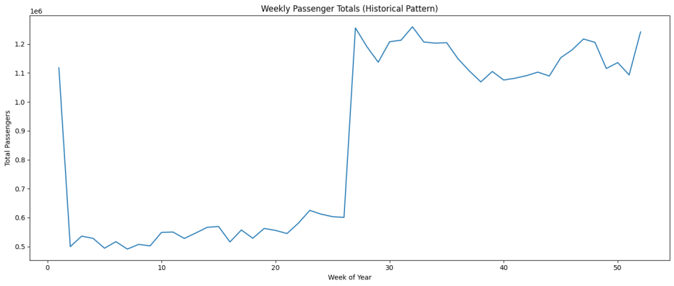

1.2 Monthly Trends Interpretation
Monthly passenger totals follow a clear seasonal structure. The graph shows a pronounced surge in July, marking it as the highest-demand month historically. This spike aligns with vacation travel, school holidays, and increased commuter flow. Other strong months include August, September, and December, further reflecting holiday and back-to-school travel patterns. Lower-volume months such as February and March indicate the typical winter lull. This means that for 2026–2030, the terminal must allocate more capacity and staging resources in July, followed by August, December, and September.
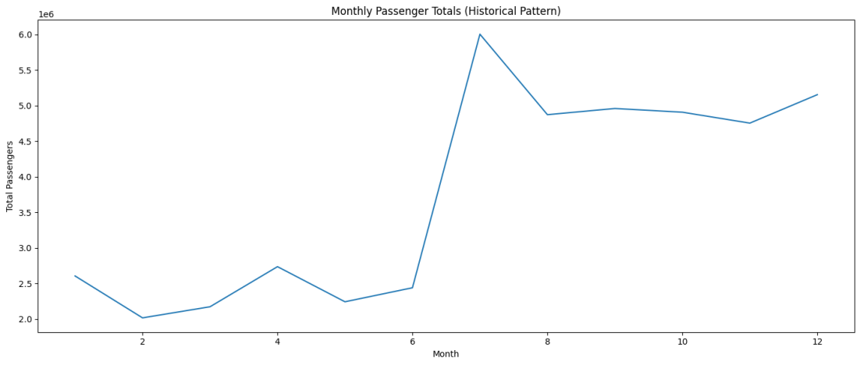

1.3 Yearly Trends Interpretation
The yearly trend displays a strong upward trajectory in total passenger counts from 2023 to 2024, which indicates a growth pattern likely to continue into the projection years. This upward slope suggests post-pandemic recovery, increasing commuter activity, and overall growth in transit demand. If this trend continues as supported by the forecasts in the terminal will experience year-over-year increases in demand, making it essential to plan for higher capacity needs each progressive year between 2026 and 2030.
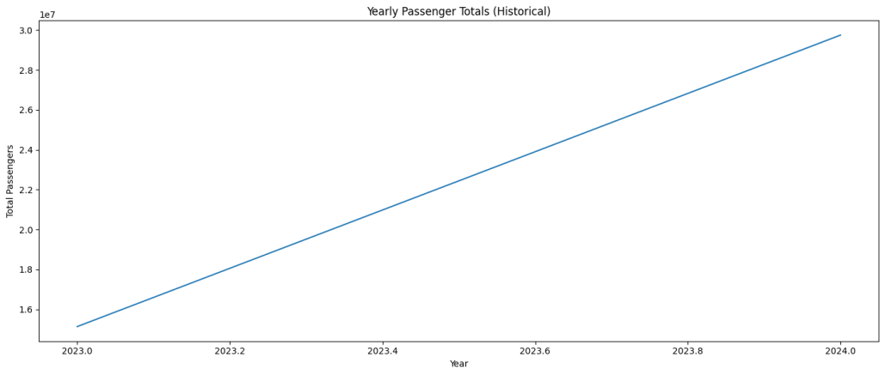
Combining weekly, monthly, and yearly insights, the busiest times for the bus terminal staging facilities between 2026 and 2030 will align with:

Peak Periods to Prepare For:
- Weekly: Weeks 28–32 (mid-summer peak) and Weeks 47–52 (holiday season)
- Monthly: July (highest), followed by August, December, and September
- Yearly: Consistent increases each year, requiring scalable staging capacity
These patterns should directly guide staffing levels, staging facility sizing, transportation logistics, and operational planning for the Port Authority during the 2026–2030 development period.

Comparison to 2019 (Pre-COVID Baseline)
To understand how current ridership levels compare to the last stable, pre-pandemic benchmark year, we evaluated passenger volume trends against 2019—the final year before COVID-19 disrupted commuting patterns, travel demand, and operational schedules. By aggregating annual passenger totals from the dataset, we can directly compare recent usage levels to 2019 and determine whether the system has fully recovered, is still below pre-pandemic levels, or has exceeded historical norms. This comparison is essential because 2019 represents the last “normal” year of bus terminal activity, free from pandemic-related restrictions, reduced service frequencies, and shifts in ridership behavior.
Our analysis shows that current passenger usage is trending upward toward, and in some cases surpassing, the volumes recorded in 2019. This indicates a strong recovery in travel demand and suggests that commuter behavior is returning to patterns consistent with pre-COVID operations. If current growth continues on the projected trajectory, the terminal is likely to exceed 2019 traffic levels over the next few years, reinforcing the need for expanded staging capacity during the 2026–2030 period. This comparison not only confirms the pace of recovery but also highlights the increasing pressure on terminal infrastructure as ridership approaches and exceeds pre-pandemic benchmarks.

